TIC-TAC-TAO PROBLEM

NAME: J.L.PUGAZH MUKILAN

REG NO: 22BCE9292 SLOT :L7+L8

TIC-TAC-TAO CODE:

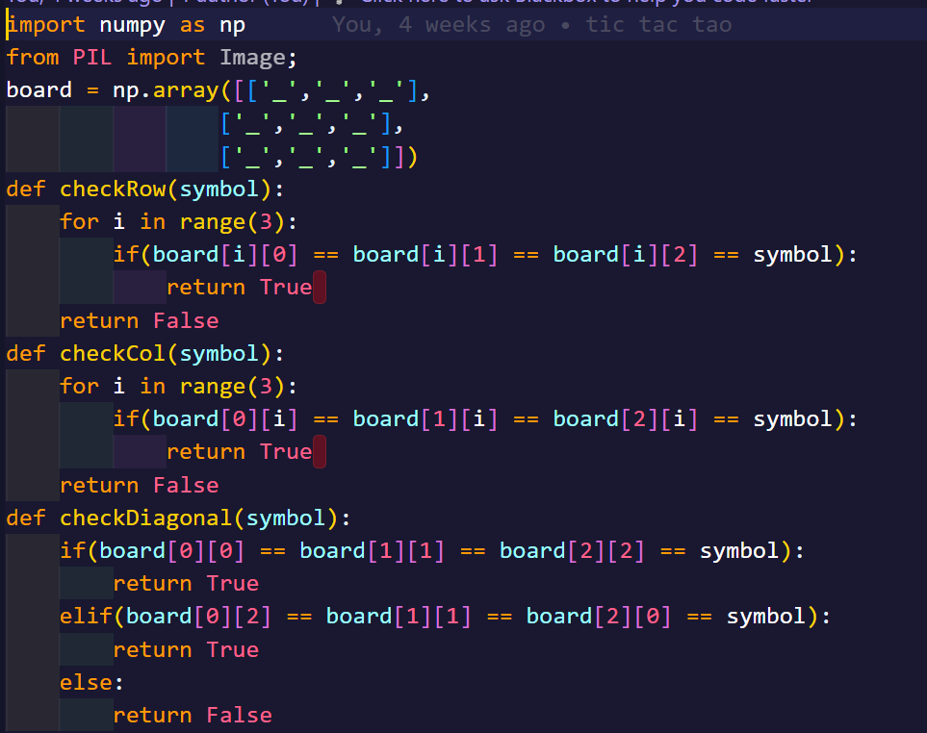

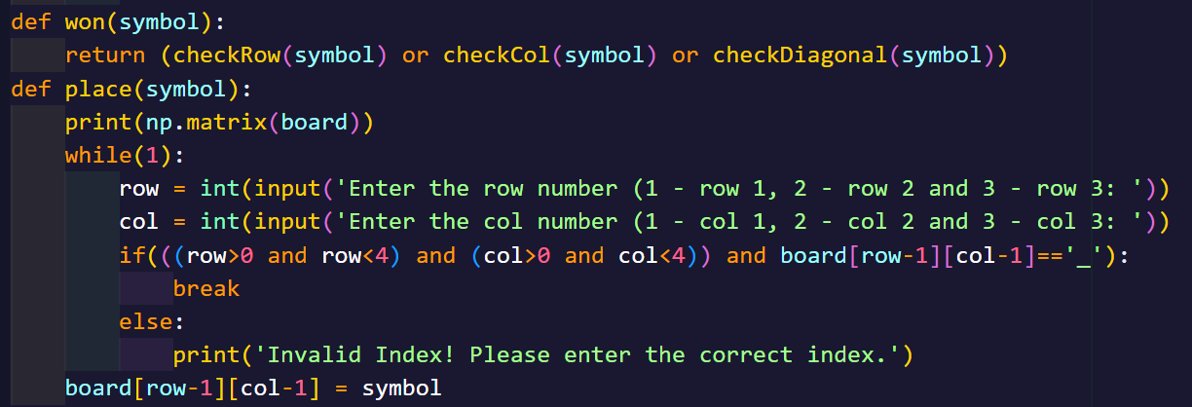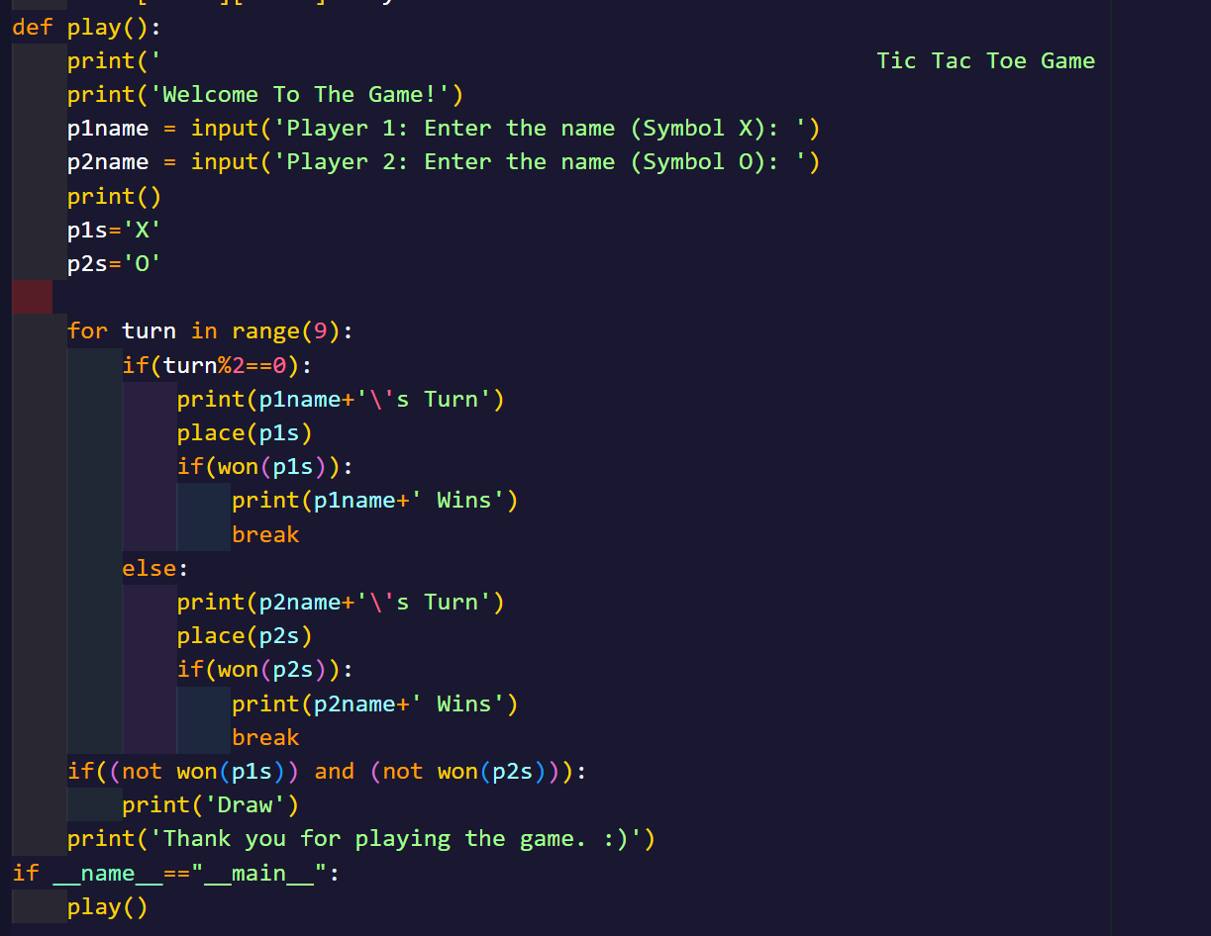

OUTPUT:

